SmartCare v0.4 - Domain Implementation Workbook
Week 7 student resource

1. UML-to-Code Trace
UML element | Python element | Implemented? | Notes
PatientRecord(name) | SQL will be used in Python using the CREATE TABLE statement to collect information. | Yes | - Data type is string.
PatientRecord(patient_id) | SQL will be used in Python using the CREATE TABLE statement to collect information. This will be indexed with CREATE INDEX statement. | Yes | - Can be used like a Medical Record Number (MRN) to call on values.
PatientRecord(mrn) | SQL will be used in Python using the CREATE TABLE statement to collect information. This will be indexed with CREATE INDEX statement. | Yes | - Can be used like an ID to call on values.
PatientRecord(phone_number) | SQL will be used in Python using the CREATE TABLE statement to collect information. | Yes | - Data type is int.
PatientRecord(medical_history) | SQL will be used in Python using the CREATE TABLE statement to collect information. This element should be a FOREIGN KEY ID connecting to another PRIMARY KEY ID in another table. | To be altered/Yes | - Could include values like diagnosis_id, allergies, hereditary_conditions, medical_concern.
PatientRecord(diagnosis) | SQL will be used in Python using the CREATE TABLE statement to collect information. This element should be a FOREIGN KEY ID connecting to another PRIMARY KEY ID in another table. | To be altered/Yes | - Could include values like datetime, general practitioner (GP), anatomical_site, diagnosis_name, clinical_stage, onset_speed, condition_status, laterized_lesion and medication.
PatientRecord(medicare_registered) | Check if Medicare is registered by the patient; it affects pricing. SQL will be used in Python using the CREATE TABLE statement to collect information. | Yes | None
PractionerEntryPortal(name) | Import the tkinter module into Python and create a GUI for the practitioner to use, with widgets to interact with to create a user input form. | Yes | None
PractionerEntryPortal(entry_id) | There should be a practitioner SQL data table as well. | Yes | - ID will be checked and validated to ensure correct user input on the GUI form.
PractionerEntryPortal(diagnosis) | Import the tkinter module into Python and create a GUI for the practitioner to use, with widgets to interact with to create a user input form. Will include a Scrollbar to see all subcomponents of diagnosis. | To be altered/Yes | - Previously mentioned in PatientRecord(diagnosis)’s notes
PractionerEntryPortal(phone_number) | Import the tkinter module into Python and create a GUI for the practitioner to use, with widgets to interact with to create a user input form | Yes | - Will have an entry widget.
PractionerEntryPortal(test_results) | Import the tkinter module into Python and create a GUI for the practitioner to use, with widgets to interact with to create a user input form. This element should be a FOREIGN KEY ID connecting to another PRIMARY KEY ID in another table. Will include a Scrollbar to see all subcomponents of test_results. | To be altered/Yes | - Could include values like test_name, result_value, units_of_measurement, normal_intervals, result_status.
ApointmentScheduling(appointment_id) | GUI buttons and scroll window for visual input from the user on the day for scheduling. Python uses a series of functions to check/save/confirm scheduling. | Yes | None
ApointmentScheduling(booked_session) | GUI buttons and scroll window for visual input from the user on the day for scheduling. This element should be a FOREIGN KEY ID connecting to another PRIMARY KEY ID in another table. | To be altered/Yes | - Could include values like appointment_id, start_time, end_time, appointment_duration, appointment_type, appointment_status.
ApointmentScheduling(datetime) | Import the datetime module to work with dates/time. Will be automatically put into the GUI platform. | Yes | None
ApointmentScheduling(medical_concern) | GUI buttons and scroll window for visual input from the user on the day for scheduling. Python uses a series of functions to check/save/confirm scheduling. | Yes | None
PaymentDetails(payment_id) | System receives/checks payment notice from the bank account that sent the money and sends receipt through email. Uses conditional statements/ functions in the code process, as well as importing smtplib to send emails. | Yes | - Payment will be physical, NOT through the system, unless it is through Medicare by a practitioner.
PaymentDetails(medical_provider) | Checks that the patient is registered for Medicare; then, once a positive answer is received, sends money to the medical provider. Uses conditional statements/ functions in the code process, as well as importing smtplib to send emails. | To be altered/yes | - Could have values like name, phone_number, billing address.
PaymentDetails(patient_id) | Checks that the patient is registered for Medicare; then, once a positive answer is received, sends money to the medical provider. Uses conditional statements/ functions in the code process, as well as importing smtplib to send emails. | Yes | None

2. Domain Invariants
Class | Invariant/rule | How protected
Booked session | appointment_status should only be one of either booked, pending, rescheduled, or cancelled. | The system should check whether it is one of the rule terms by creating a list with these values and using if conditional statements and the not operator.
PatientRecord | medicare_registered should only be equal to yes/no, Boolean value data types. | Translate the input from the SQL table to Boolean value through bool() and then return it to the user.
PatientRecord | phone_number should only be of data type int. | Translate the input from the SQL table to an int value through int() and then return it to the user.

3. Composition / Inheritance Decisions
Relationship | Decision | Rationale
Medical_Provider has a phone_number | Yes | Only one instance.
Medical_History is a diagnosis | Yes | Through diagnosis_id, all values are included.
BookedSession is a AppointmentScheduling | Yes | Through appointment_id, all values are included.

4. AI Pair-Programming Record
AI contribution | Conforms? | Decision | Reason | Verification

5. Updated UML
Insert updated UML only if implementation revealed a justified design change. Explain every change.
Changes were made because of these table entries:
PatientRecord(medical_history) | SQL will be used in Python using the CREATE TABLE statement to collect information. This element should be a FOREIGN KEY ID connecting to another PRIMARY KEY ID in another table. |  | To be altered/Yes |  | - Could include values like datetime, general practitioner (GP), anatomical_site, diagnosis_name, clinical_stage, onset_speed, condition_status, laterized_lesion and medication.
PatientRecord(diagnosis) | SQL will be used in Python using the CREATE TABLE statement to collect information. This element should be a FOREIGN KEY ID connecting to another PRIMARY KEY ID in another table. |  | To be altered/Yes |  | - Could include values like datetime, general practitioner (GP), anatomical_site, diagnosis_name, clinical_stage, onset_speed, condition_status, laterized_lesion and medication.
PractionerEntryPortal(id) |  | There should be a practitioner SQL data table as well. |  | Yes | - ID will be checked and validated to ensure correct user input on the GUI form.

- Changes will be made to ensure patients can view practitioner information easily through effective data collection, and because of the vagueness associated with elements like medical_history and diagnosis, these should be more specific to help users understand. Additional class elements should be added for further clarification as well.

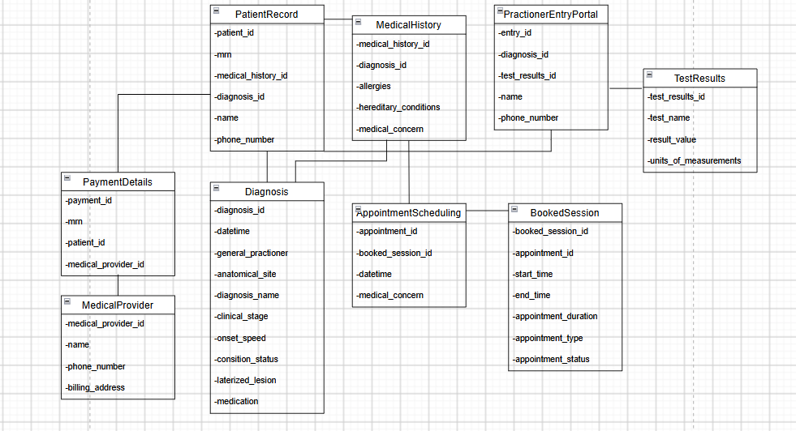
References:
Python.org, 2019, email: Examples — Python 3.7.3 documentation, Viewed 25th Sept 2026, https://docs.python.org/3/library/email.examples.html

